**WEBSITE HOMEPAGE**

There is a navigation bar at the top, each with its own function.

* Home will redirect to the homepage.
* About has two options, about us and about tutors.
* Subjects have five options (like the subject names stated in the pictures below, which are also clickable and redirect to the subject information).
* Contact, more details about the company.
* Register and login button, which will navigate to their respective page.

**Home**

**About**

**About/The Team**

**About/The Tutors**

**Subjects**

**Subjects/Mathematics**

Above is a sample for the subject option (There are 5 subjects in total). Each use the same layout.

**Contact**

**Registration Page**

All details are required in order to continue the process. To go back to the homepage, users can click on the logo or “Login Now” to go to the login page. If the username has already been taken, it will display

and then be redirected back to the registration page.

**Login Page**

Users can go to the homepage by clicking the logo, or they can go to the registration page by clicking "Register Now." If the user enters the wrong username or password, it will display

There is a password reset implementation when a user forgets their password.

Below are the steps:

1. Enter the email address

1. A code verification will be sent.

1. Input the code given and submit it.

1. Input the new password.

1. A successful popup appeared and redirected to the login page.

**Dashboard (Student)**

When a user registers on the registration page, they will automatically be given the student role. Only administrators can change the level of the user. The student dashboard below will be shown when the student has logged in successfully.

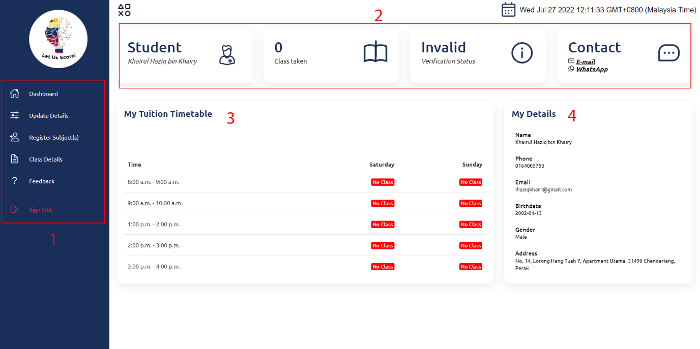

1. Student’s navigation bar.
2. A student’s quick report. It will display the student’s name and a male or female icon according to gender. For verification status,  whether the student has registered for any classes, it will either display Invalid, Pending, Accepted, or Declined.
3. In the tuition timetable, in the red box, if the user has been verified for the classes taken, there would be a green box with the day of the classes.
4. Details about the student.

**Update Details (Student)**

Update their own user details. Note that the details in the grey box cannot be changed or edited. The next step is that the user must click the save icon.

And data is saved.

**Register Subject (Student)**

Steps:

1. Choose the desired slot on which day for each subject. It is not necessary to choose all, and at least one input must be chosen in order to submit. If the slots for the class are full, the user cannot choose the button.
2. Upload payment proof (each class costs RM50). The file format must be in a picture or pdf format and not exceed 5MB. (The payment proof file will then be uploaded to the server and will be renamed as studentUsername_currentDate.fileformat).
3. Reset button to reset the student’s input and submit button to submit the registration.

When the student successfully submits the registration,

1. the option "Register Subject(s)" in the navigation will no longer be displayed.
2. the verification status in the student dashboard will be changed to Pending.

If an admin has accepted the the student’s registration, below is the timetable for the student

**Class Details (Student)**

It is currently empty as admins have not accepted the student’s registration yet. If an admin has approved the registration, below is the output.

The table shows the student’s class details, including the class’s tutor details.

**Feedback (Student)**

Students can give feedback by submitting the form above. It must contain the title and a comment. Both are necessary. Note that admins cannot see who made a certain type of feedback (highly confidential). After it has been submitted, it will be shown in the "My Feedbacks" table.

The new feedback is then saved and can be seen above.

**Dashboard (Admin)**

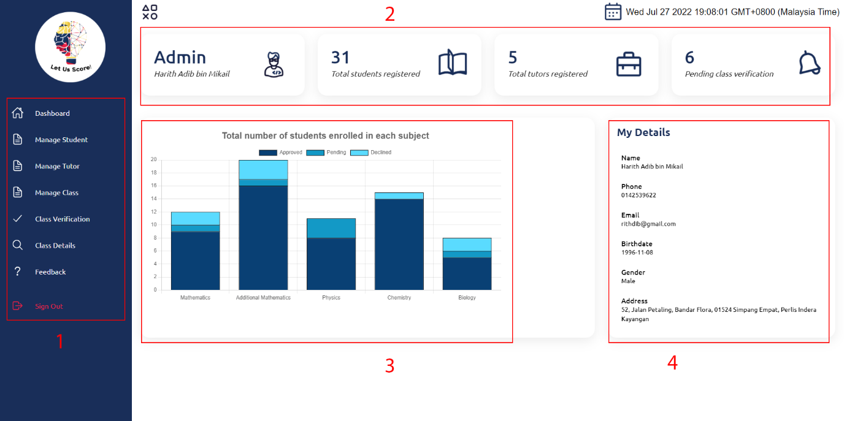

1. Administrator’s navigation bar.
2. An admin’s quick report. It will display the admin’s name. The numbers for total students and tutors registered and also total classes pending need to be verified.
3. A graph which shows the total number of students enrolled can be seen with each subject.
4. Details about the admin.

**Manage Student (Admin)**

All of the details and functions for “Manage Tutor” would be the same as for “Manage Student”, but the data would be changed to be for tutors.

This is where admins can manage the student details. After a change has been made, the admin can click on the save button

and be redirected back to the manage student page.

There is also a search button to search for a certain student. For example, to search for a student named Aleya, which will then be output like

If you see on the top right side, there is a button to export data to CSV (can be opened with Microsoft Excel). Let’s say the button is clicked, a CSV file named "studentList (currentDate).csv" will be downloaded (For the tutor it would be “tutorList (currentDate).csv).

**Manage Class (Admin)**

Admins can edit class details here, and click the save button. Note, the gray box cannot be edited.

There is also an option to export data to CSV same as shown before this which would be named as “feedbackList (currentDate).csv”.

**Class Verification (Admin)**

Below is the continuation,

Class Verification is where an admin will verify whether any student who has applied for the registration is accepted or declined. Admin has the ability to click on the picture for a bigger proof of payment image. For example,

Let’s say we approve Haziq’s application,

the data will be then moved to the approved and declined applications table below. And the verification status for Haziq will be changed to Accepted in the student dashboard.

**Class Details (Admin)**

Option to see class details for administrators. For example, class for Physics on Sunday.

**Feedback (Admin)**

There is an option for administrators to view every piece of feedback made by the students. There is also a delete button to delete the feedback. On the top right hand side, the export data to CSV is the same as shown before, except it will show all the feedback and will be named as "feedbackList (date).csv".

**Dashboard (Tutor)**

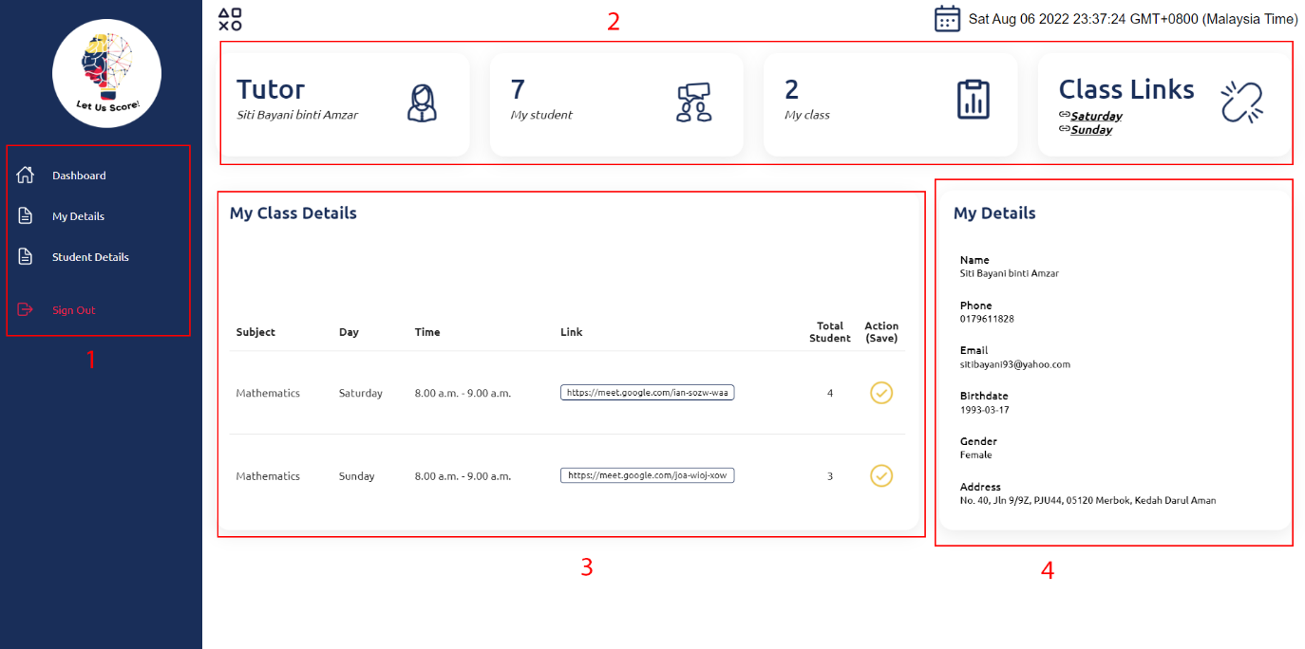

1. Tutor’s navigation bar.
2. Tutor’s quick report. It will display the tutor’s name. The numbers for total students for the tutor and the total tutor’s total classes. Class links provide a quick link to the Google meet link.
3. Shows the details about the tutor’s classes and the ability to change class link url.
4. Details about the tutor.

When new class link is updated,

**My Details (Tutor)**

Provide the ability to change the tutor’s personal details.

When save button is clicked,

**Student Details (Tutor)**

The tutor can choose which day all the students' details in his/her class will be displayed.

For example, “Saturday” button is clicked,

